

Twitter

**Product Dissection for Twitter**

### **Company Overview:**

Twitter is a globally recognized social media platform and microblogging service that allows users to share and discover short messages called tweets. Founded in 2006, Twitter has grown into a powerful communication tool with over 330 million monthly active users as of my last update in January 2022. Enabling individuals, organisations, and celebrities to interact with diverse audiences in real time, the platform has become an integral part of the online environment, serving as a source of real-time news, trends, and updates. Twitter has also played an important role in shaping public debate and providing a platform for social and political movements.

### **Product Dissection and Real-World Problems Solved by Twitter:**

Twitter, through its innovative product design and user-friendly interface, solves real-world problems by promoting immediate and widespread communication. The platform's character-limited tweets encourage brevity and rapid information dissemination, making it a valuable tool for breaking news, emergency alerts and real-time updates during emergencies. Twitter has played an important role in connecting people globally, enabling the exchange of ideas, opinions and information across diverse communities. It serves as a catalyst for social and political movements, providing a platform for activism and advocacy. The hashtag feature introduced by Twitter has become a powerful planning tool for social campaigns. Additionally, the platform facilitates customer feedback, allowing businesses to connect directly with their audience.

In conclusion, Twitter's product design not only promotes efficient and concise communication but also addresses real-world challenges by serving as a dynamic and influential medium for information sharing, community building, and social influence.

### **Case Study: Real-World Problems and Twitter's Innovative Solutions**

Twitter, a leading social media platform, has not only revolutionised the way we share and consume content but has also addressed significant real-world challenges through its innovative features. By identifying user needs and leveraging technology, Twitter has positioned itself as a solution-driven platform that fosters connections, encourages self-expression, and enhances digital interactions.

**Problem 1: Information Overload and Filtering**

**Real-world Challenge:**

One significant real-world issue is the overwhelming amount of information available online, making it challenging for users to filter through the noise.

**Twitter’s Solution:**

Twitter addresses this by implementing algorithms that prioritise relevant content based on user preferences, engagement history, and trending topics. The "Home" timeline, for instance, employs machine learning to curate a personalised feed, ensuring users see the most pertinent tweets.

**Problem 2: Misinformation and Fake News**

**Real-world Challenge:**

The proliferation of misinformation on social media is a critical problem with societal consequences.

**Twitter’s Solution:**

Twitter employs a multi-faceted approach to tackle this issue. They collaborate with fact-checking organisations, label misleading content, and utilise machine learning algorithms to identify and reduce the visibility of false information. Additionally, the platform encourages user reporting, fostering a community-driven effort to combat misinformation.

**Problem 3: Online Harassment and Abuse**

**Real-world Challenge:**

Creating a safe online environment is a persistent challenge.

**Twitter’s Solution:**

Twitter has implemented features to mitigate harassment, such as the ability to block and report users, keyword filtering, and algorithms that identify and limit the reach of abusive content. The company continuously refines these tools and collaborates with external organisations to enhance user safety and combat online abuse effectively.

**Problem 4: Accessibility**

**Real-world Challenge:**

Ensuring that Twitter is accessible to users with diverse needs, including those with disabilities, is crucial.

**Twitter’s Solution:**

Twitter has made strides in this area by incorporating accessibility features, such as alt text for images and improved keyboard navigation. They actively seek user feedback and engage with accessibility communities to refine their features, striving to make the platform more inclusive for all users.

**Conclusion:**

In conclusion, Twitter tackles real-world problems by innovatively addressing issues such as information overload, misinformation, online harassment, and accessibility concerns. Through a combination of algorithmic enhancements, collaboration with external organisations, and user-driven features, Twitter continues to evolve its platform to create a safer, more informative, and inclusive online space.

Top Features Of Twitter:

**Tweets:** The fundamental feature of Twitter, tweets are short messages with a character limit of 280 characters. Users can share text, links, images, and videos in these concise updates.

**Retweets and Likes:** Users can amplify content they find interesting or informative by retweeting it to their followers. Likes, represented by a heart icon, indicate approval and contribute to the visibility of a tweet.

**Followers and Following:** Users can follow other accounts to see their tweets in their timeline. This asymmetrical relationship allows for tailored content consumption.

**Hashtags:** Hashtags categorise content and make it discoverable to a wider audience. Users can click on hashtags to explore related tweets and trending topics.

**Mentions**: Users can mention others in their tweets by using the "@" symbol followed by the username, enabling direct communication and notification to the mentioned user.

**Lists:** Twitter allows users to create lists to organise accounts they follow. This feature helps users streamline their feed by categorising accounts into different groups.

**Media Attachments:** Users can include images, GIFs, videos, and polls in their tweets, enhancing the variety and engagement level of the content shared.

**Direct Messages (DMs):** Private conversations between users can take place through direct messages. This feature allows for more personalised and confidential communication.

**Trends:** The "Trending" section displays popular hashtags and topics based on user engagement, providing insight into current events and discussions.

**Profile Customization:** Users can customise their profiles with a profile picture, header image, bio, and pinned tweets to express their identity and interests.

**Twitter Analytics:** Available for business accounts, Twitter Analytics provides insights into tweet performance, audience demographics, and engagement metrics.

**Bookmarks:** Users can save tweets to a private "Bookmarks" section for later reference, allowing easy access to content of interest.

Schema Description:

The schema reflects Twitter's emphasis on user-generated content, real-time communication, and the variety of content shared on the platform. The selections of units and relationships align with Twitter's goal of providing a dynamic and interactive social media experience. Relationships allow for flexibility in categorising tweets. The schema design supports efficient querying, reflecting Twitter's need for fast and responsive data retrieval to provide a seamless user experience.

**User Entity:**

The user entity contains information about each user:

* **UserID (Primary Key):** A unique identifier to each user.
* **Username:** A chosen username for the user’s account.
* **Bio:** Short description about yourself.
* **ProfilePicture:** A picture of the user.
* **HeaderImage:** Cover image or A banner.
* **Email:** The user's email address for account-related communication.
* **JoinDate:** The date when the user created an account in Twitter**.**

**Tweet Entity:**

A user Broadcast short post.

* **TweetID (Primary Key):** A unique identifier for each tweet.
* **Content:** Concise and publicly shared message.
* **Timestamp:** Represent data and time when the tweet is created.
* **UserID (Foreign Key referencing User):** The user who created the tweet.
* **LikesCount:** Represent a number of times a tweet has been marked.
* **RetweetsCount:** Represent that how many times a tweet has been reposted.

**Hashtag Entity:**

* **HashtagID (Primary Key):** A unique identifier for each hashtag.
* **Text:** The actual text of the hashtag.
* **TweetID (Foreign Key referencing Tweet) :** Referencing to users who tweet.

**Media Entity:**

* **MediaID (Primary Key):** Uniquely identifies media attachments.
* **MediaType:** Represents the type of media attachments.
* **URL:** A uniform resource locator.
* **TweetID (Foreign Key referencing Tweet):** Referencing to users who tweet.

**List Entity:**

* **ListID (Primary Key):** Uniquely identifies user-created lists on twitter.
* **Name:** Name of the lists.
* **UserID (Foreign Key referencing User):** The user associated with the lists.

**DirectMessage Entity:**

* **MessageID (Primary Key):**Unique identifiers assigned to each private message.
* **Content:** information shared between the users.
* **Timestamp:** Represent data and time when the text is created.
* **SenderID (Foreign Key referencing User):** facilitate private communication.
* **ReceiverID (Foreign Key referencing User):** user receiving a direct message.

**Moment Entity:**

* **MomentID (Primary Key):** A unique identifier for a curated collection of tweets.
* **Title:** summarises the theme or topic of a moment.
* **Timestamp: :** Represent data and time when the moment is created.
* **UserID (Foreign Key referencing User) :** The user associated with the moment.

**Bookmark Entity:**

* **BookmarkID (Primary Key):** Linking a user to a specific bookmarked tweet.
* **UserID (Foreign Key referencing User):** The user associated with the bookmark.
* **TweetID (Foreign Key referencing Tweet):**The tweet associated with the bookmark.

**Relationships are:**

**User-tweet relationship:** one-to-many (a user can have many tweets, but each tweet is associated with a single user)**.**

**Tweet-hashtag relationship:** many-to-many (a tweet can have multiple hashtags, and a hashtag can be associated with multiple tweets).

**Tweet-media relationship:** one-to-many (a tweet can have multiple media connections, but each connection belongs to a single tweet).

**User-list relationship:** one-to-many (a user can have multiple lists, but each list is associated with a single user)**.**

**User-direct message relationship:** one-to-many (one user can send/receive multiple direct messages, but each message involves two users).

**User-moment relationship:** one-to-many (a user can create multiple moments, but each moment is associated with a single user).

**User-bookmark relationship:** one-to-many (a user can have multiple bookmarks, but each bookmark is associated with a single user)**.**

**ER Diagram:**

The ER-diagram for Twitter aims to visually represent the data model underlying the platform, highlighting key entities such as Users, Tweets, Hashtags, Media, Lists, Direct Messages, Moments and Bookmarks with their respective attributes. Show how figures interact and the salience of their relationships. Users and tweets serve as the basic units, with various other entities attached to them reflecting the dynamic nature and variety of features of Twitter. Relationships including one-to-many and many-to-many associations will be depicted to capture the complex connections between the various components of the platform. This ER-diagram will provide a comprehensive overview of Twitter's functionality and data structure supporting user interactions.

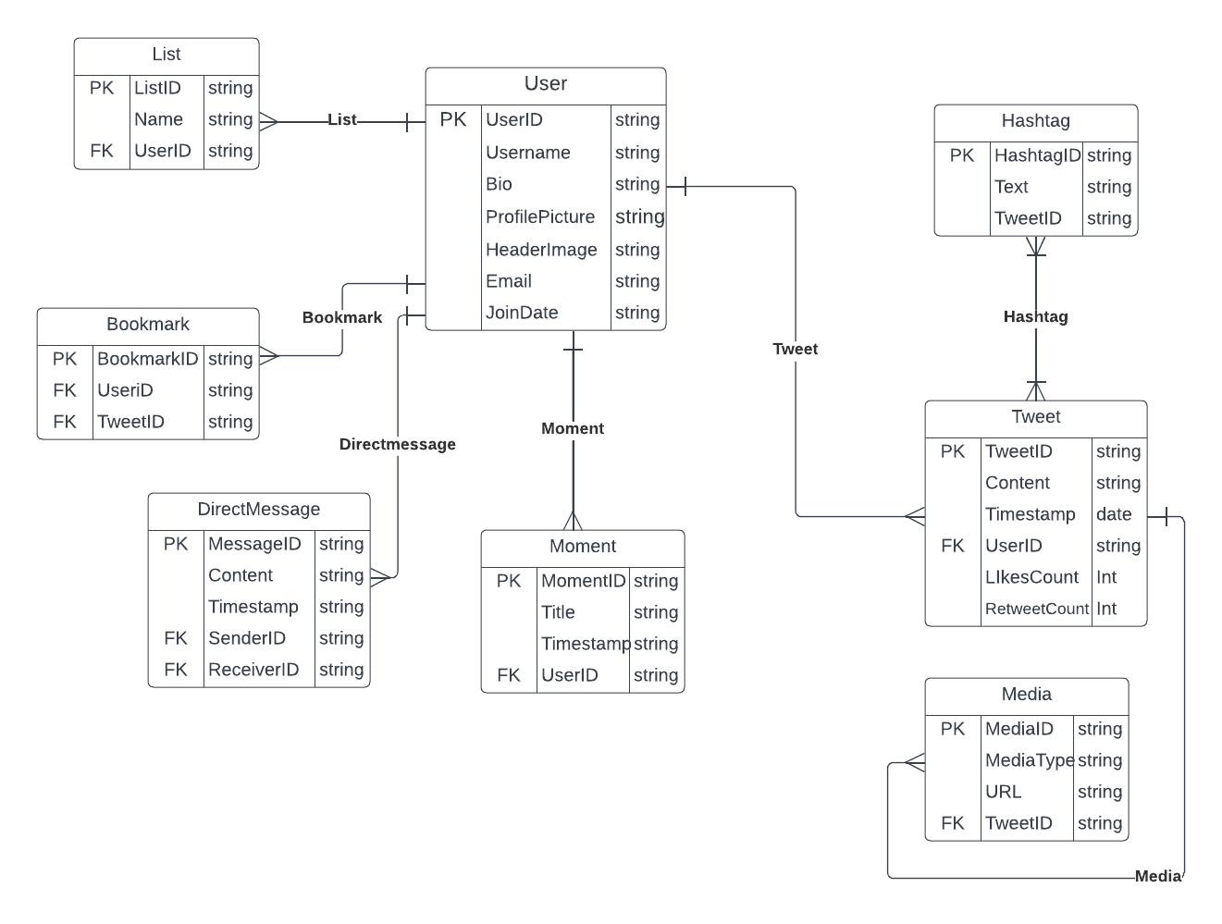

**Conclusion:**

In this case study, we delved into the design of Twitter's schema and Entity-Relationship diagram.Twitter's innovative solutions address real-world problems by providing a dynamic platform for crisis communication, implementing measures to combat misinformation, facilitating concise public discourse, and providing businesses with a direct channel for customer feedback and interaction. These features contribute to the platform's importance in addressing contemporary challenges and enhancing communication across domains.By understanding this scheme, we understand how Twitter effectively manages the complexity of user interaction and content sharing, contributing to widespread adoption and continuous growth in the world of social media.